**COMSATS UNIVERSITY ISLAMABAD**



**SUBMITTED BY:**

**MARYAM MUKHTAR**

**REGISTRATION NO:**

**FA24-BBA-123**

**SUBMITTED TO:**

**PROF. MUFEEZA MANZOOR**

**ASSIGNMENT TITLE:**

**EXERCISE NO. 1**

**DEADLINE DATE:**

**OCTOBER 19th, 2025**

**PART 1: VARIABLES AND DATA TYPES**

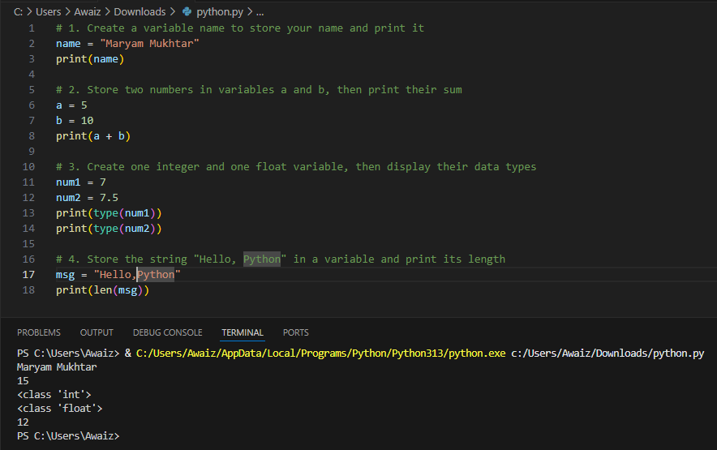

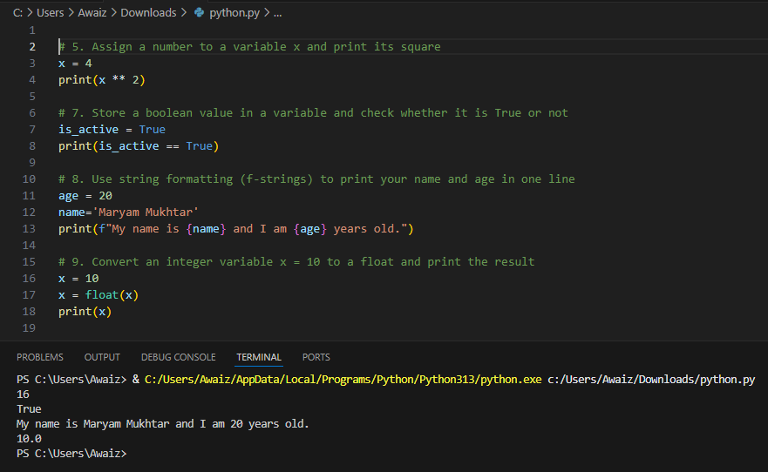

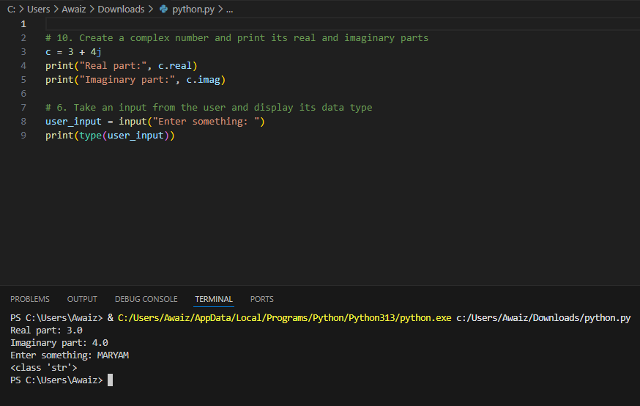

**PART 2: OPERATORS**

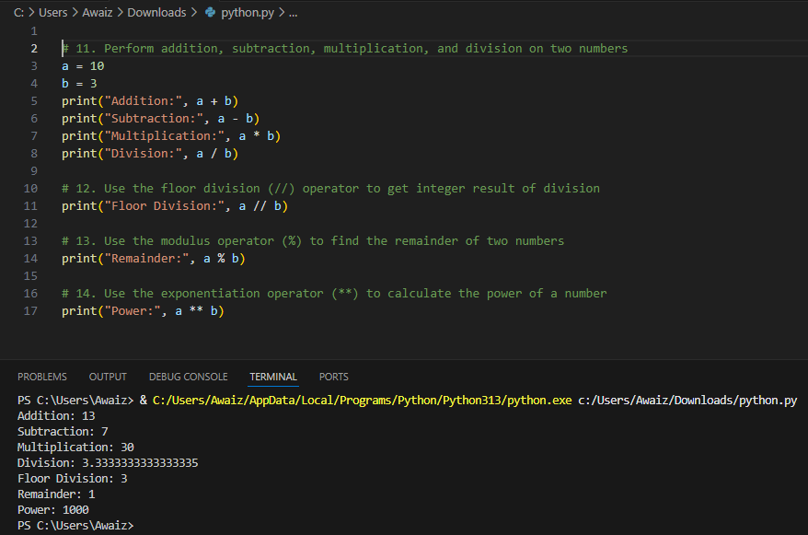

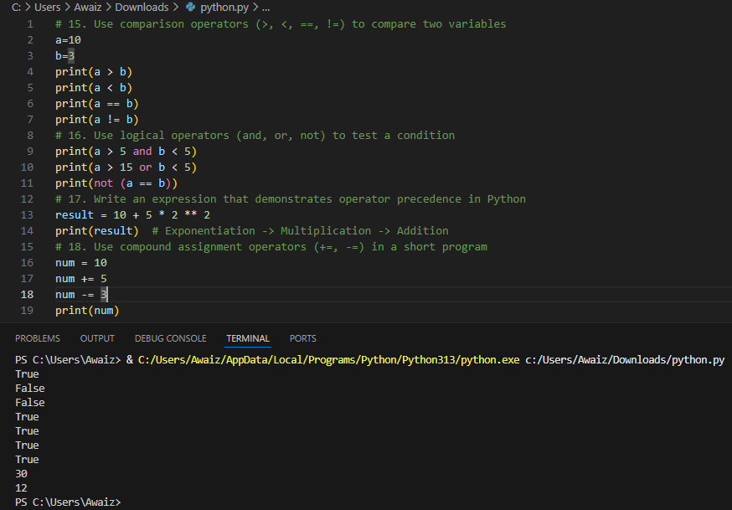

**PART 3: CONDITIONAL STATEMENTS**

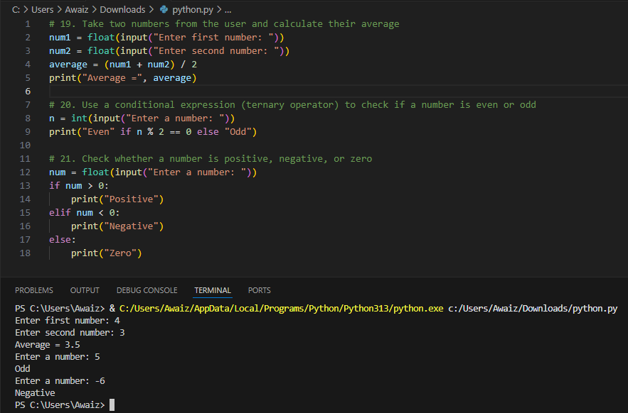

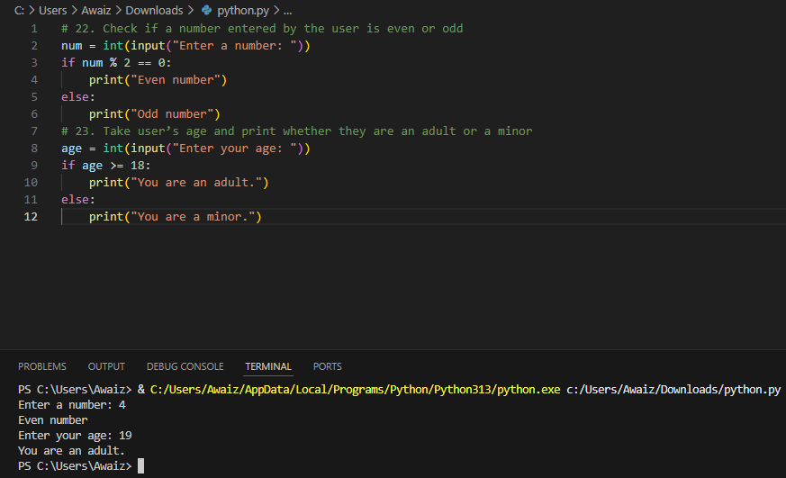

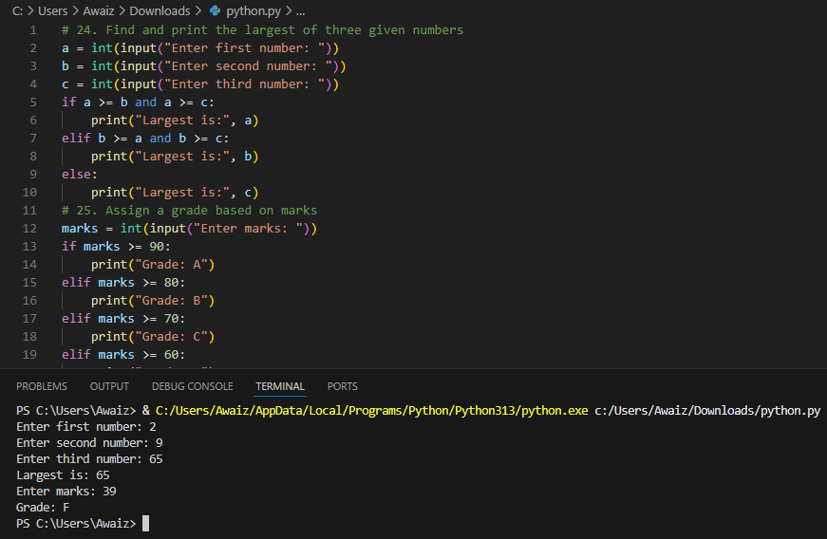

**PROGRAM CODE:**

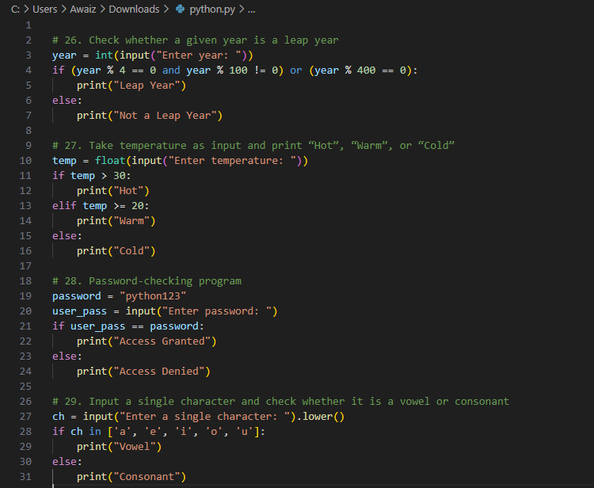

**OUTPUT :**

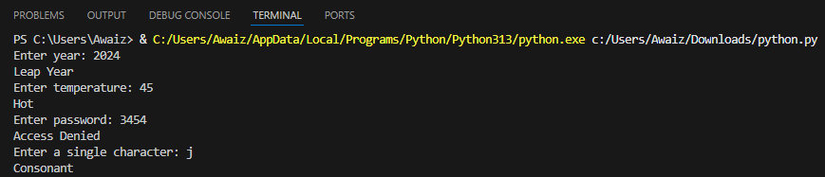

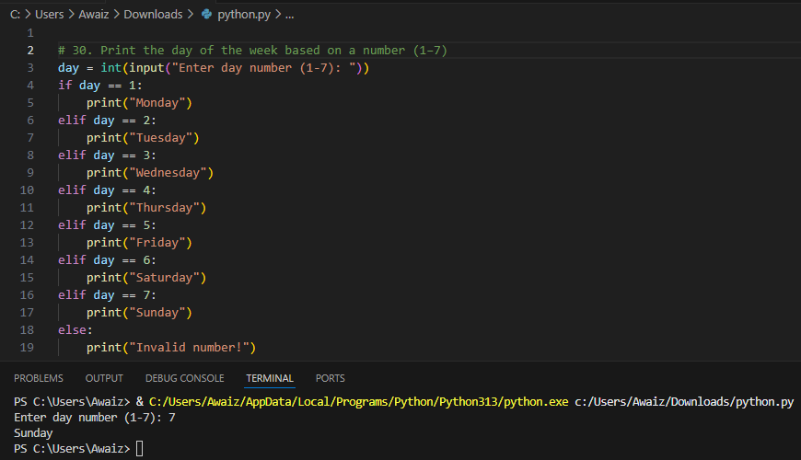

**PART 4: LISTS**

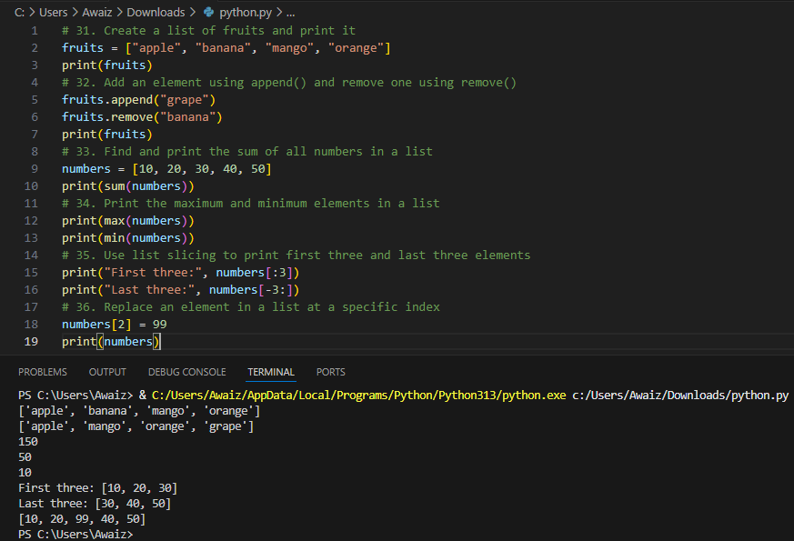

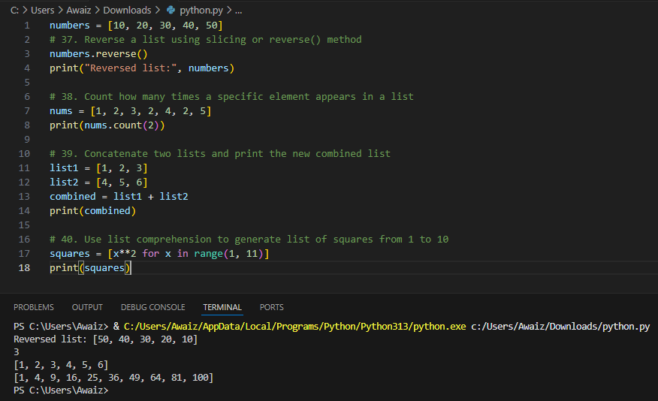

**PART 5: TUPLES**

**PROGRAM CODE:**

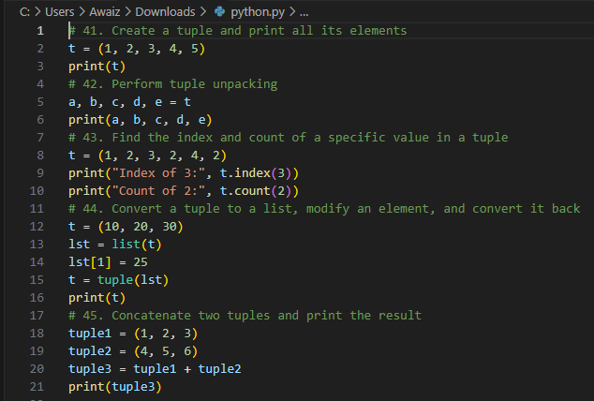

**OUTPUT:**

